INFORMATION SYSTEMS 2A: ASSIGNMENT 2
Full Name: Kandyce Smit Student Number: ST10467645

Lecturer: Moses Olaifa
Module Code: INSY6211

Table of Contents
Question 1: 2
1.1) 2
Question 2 4
2.1) 4
2.2) 4
Question 3 6
3.1) 6
3.2) 7
Proposed Interface Designs for the GPS Navigation Functionality of the Airport Customer Relations Management System 7
Addressing Usability, Visibility and Affordance Concepts 11
Question 4 14
4.1) 14
4.2) 15
4.3) 15
4.4) 16
References 17

Question 1:

1.1)

The following System Vision Document was developed using the System Vision Document template given by Satzinger, Jackson and Burd (2015) and IBM (2025).

System Vision Document
Airport Customer Relations Management System

Problem Description
Recently, the airport completed an upgrade to its infrastructure with the addition of international flight services, resulting in an increase in the number of tourist arrivals at the airport. Although the increased tourist traffic is generally good news for the airport, it does create a problem. The airport needs a way to be able to deliver good customer service to every traveller.
Currently, a major deficiency exists in terms of being able to provide travellers with timely and accurate information. This lack of effective communication results in a lower quality of service than would otherwise exist. Additionally, if something goes wrong and a traveller requires assistance, for example, getting lost, experiencing illness or injury, their ability to get the assistance they require could potentially be hindered. Therefore, the airport should implement a system designed to enhance the overall customer experience while allowing them to continue to develop and sustain strong customer relationships.

System Capabilities
The proposed system will offer the following functionalities:
- Provide real-time flight schedules, delays, and boarding information
- Display airport facility maps showing the locations of airport facilities
- Offer GPS-based directional capability to assist passengers in finding gate locations and other areas of interest inside the terminal
- Allow passengers to quickly connect to medical and emergency services when needed
- Be accessible through both airport kiosks and a downloadable mobile application

Business Benefits
Implementation of the proposed system is anticipated to result in several beneficial outcomes for the airport:
- Improved customer satisfaction due to ease of accessing necessary information
- Enhanced passenger experience, leading to sustained customer relationships
- Enable faster and more efficient response times for emergencies involving passengers.
- Easier access to airport services and facilities via improved navigation and informational systems
- The airport's image will be enhanced as a modern, customer-focused international travel destination
- Smooth and hassle-free travel experiences for domestic and international visitors

Question 2

2.1)

Functional requirements explain which of the many possible features a computer system must include to support the needs of its users (Satzinger, et al., 2015). Therefore, functional requirements describe what a system must do and how it will operate as users interact with either the system itself or other systems (GeeksforGeeks, 2026). Three functional requirements were identified for the Airport Customer Relations Management System:

- The system must be able to obtain and show current flight data, including flight times, delays, gate changes, and boarding announcements, so that passengers will always know the status of their flights.
- The system must be able to assist passengers by providing GPS directions from their present location to boarding gates and various other points of interest at the airport such as restaurants, shops, etc. This means that travellers will be able to navigate the airport quickly and easily without getting lost.
- The system must allow passengers to call for immediate medical assistance through the app such as calling on-site medical staff or ambulance services. This will enable people who suffer an injury, illness or an emergency at the airport to get prompt help immediately without delay, which ultimately will increase overall passenger safety and support at the airport.

2.2)

Non-functional requirements of a system define how a system performs its functional requirements as opposed to describing what a system does (Reqtest, 2012). Non-functional requirements include requirements related to performance, availability, security and usability (AltexSoft, 2023). Two non-functional requirements were identified for the Airport Customer Relations Management System:

- The system must allow passengers to easily use the application regardless of their level of technical knowledge, age, or previous experience using applications. The system should provide support through clear navigation and user-friendly design so that first-time users can access a feature or service in the shortest amount of time possible. International airports serve travellers who vary significantly in terms of nationality, language proficiency and technological ability; thus, making the system simple to understand is crucial.
- The system must protect all passenger personal information by always encrypting the data while in use. Passenger data will not be accessible by unauthorised parties and therefore remain private and compliant with regulatory requirements regarding personal data protection.

Question 3

3.1)

The following Entity Relationship Diagram (ERD) represents the entities, attributes, and relationships based on the given business rules and was developed using the Entity Relationship Diagram template given by Satzinger, Jackson and Burd (2015) and was drawn using draw.io.

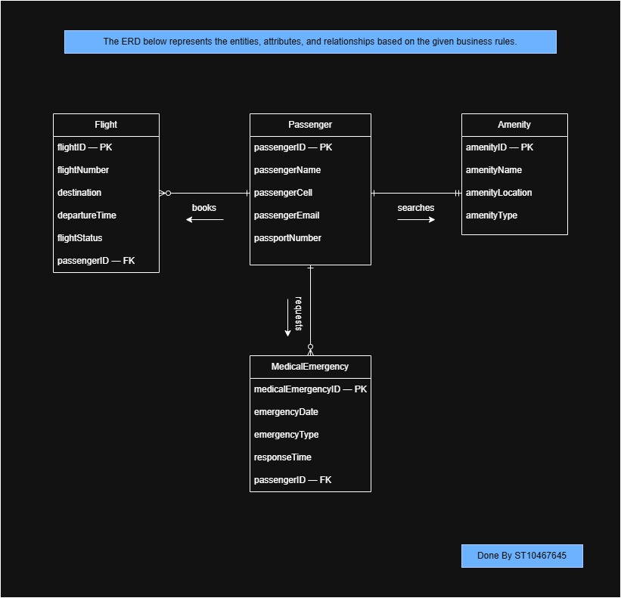

3.2)

Proposed Interface Designs for the GPS Navigation Functionality of the Airport Customer Relations Management System

Interfaces were designed using Figma. Each screen is presented as a wireframe (left) and a mobile application preview (right).
Screen one – Login in

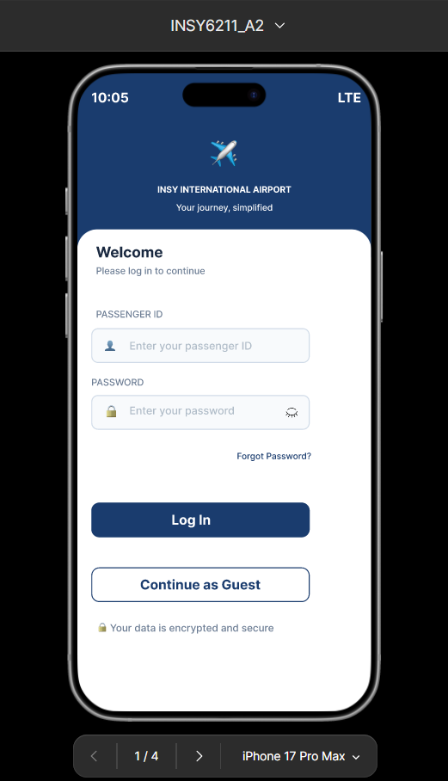
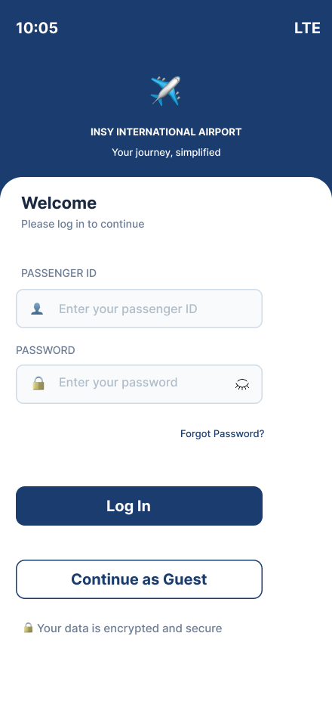
Screen 2 – Home Page: Selecting GPS Navigation
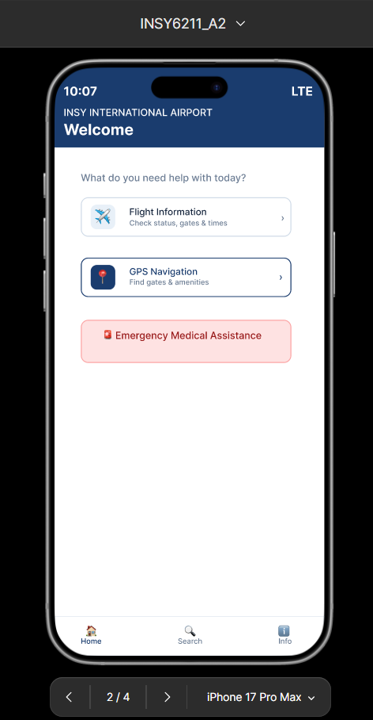
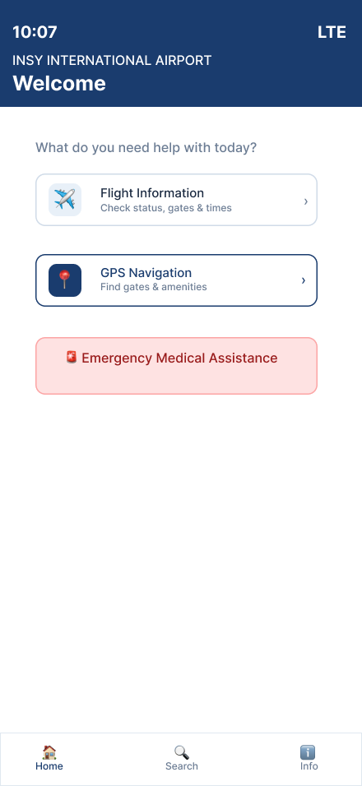

Screen 3 – Search Page: Searching for gate or amenity

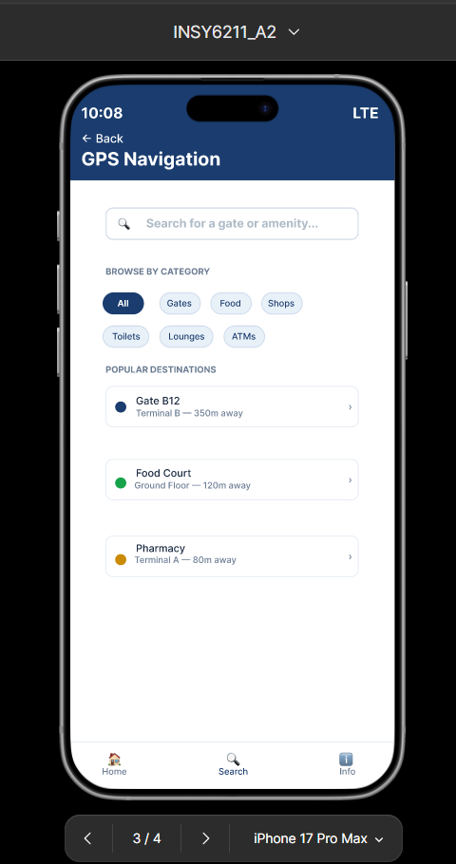
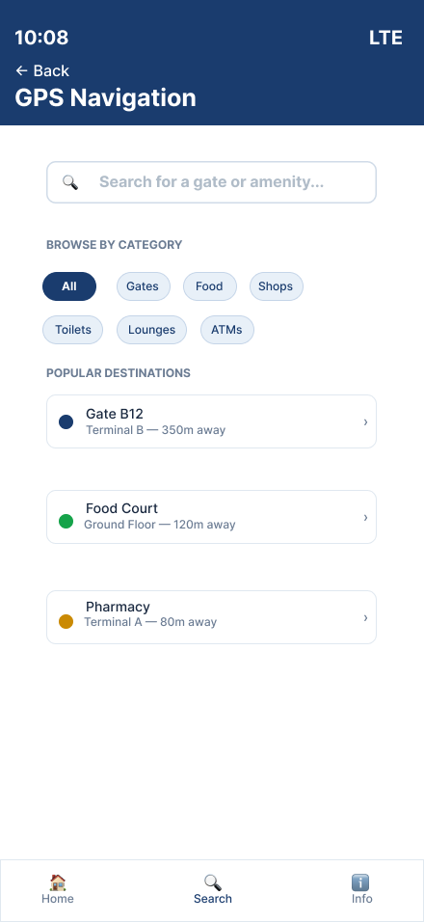

Screen 4 – Information Page: Directions to gate or amenity

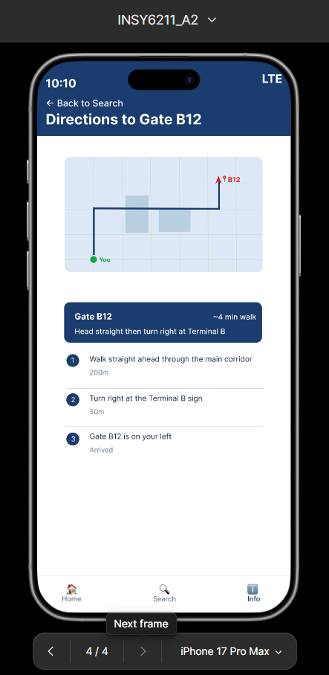
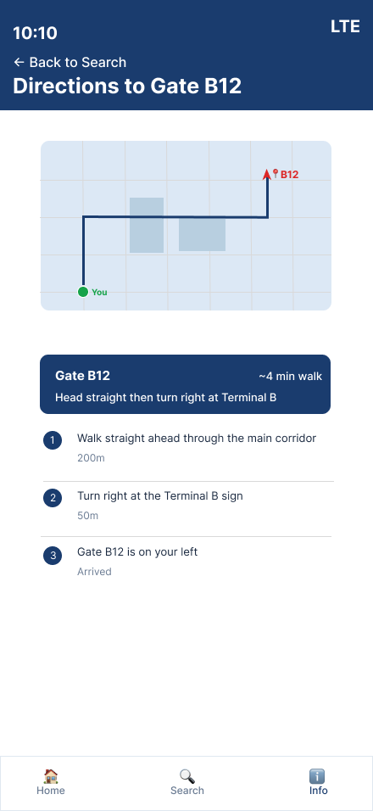

Addressing Usability, Visibility and Affordance Concepts
The Airport Customer Relations Management System’s GPS navigation function was chosen as the primary functionality for designing this interface. The GPS navigation function enables passengers to identify their location at the airport, find their way to the gate that will be used by their flight, find the airport's amenities such as restaurants or shops, and find other locations of interest inside the terminal. A total of four different screens were developed to enable the GPS navigation function: the login page, the home/welcome page, the search/navigate page and the map/directions page. The interfaces were designed with the following core concepts in mind:

Usability
Usability relates to how simple and pleasant it is to use a systems’ functions. Five usability elements measure how usable an application is: learnability, efficiency, memorability, errors, and user satisfaction (Nielsen Norman Group , 2012). Learnability relates to how easily new users can complete a simple task when using the design for the first time, while efficiency relates to how quickly users can accomplish a simple task after having previously completed that same task (Nielsen Norman Group, 2019).
The usability aspect of the four screens designed was very important. The "Login Screen", had two clearly defined areas where passengers could enter their Passenger ID and Password. Each area was labelled above the entry field for clarity of the data that passengers need to provide. In addition, there was a "Continue as Guest" button added to allow passengers to use this system without needing to create an account. This design feature promotes learnability as first time users can get into the help section without being required to create an account. The "Home Screen," has only three major selections available: flight information, GPS navigation, and emergency assistance. Therefore, the Home Screen is free from clutter, and the passenger is not overwhelmed with too much information. As per Nielsen's Principle of Aesthetic and Minimalist Design; "Interfaces should be designed to display only relevant and necessary information." (Nielsen Norman Group , 2012). On the "Navigation Search Screen," there is a large search box located at the top of the screen. Below the search box there are category filter chip boxes. Therefore, passengers will either be able to search for a specific location or select one of several categories to view possible destinations. This will result in fewer steps in finding a destination thereby improving efficiency. Lastly, on the "Map and Directions Screen," there are numbered step-by-step instructions located below the map. These instructions are designed to assist passengers of various literacy levels and technical ability to understand the route they need to take. Since many people travel through international airports they come from different countries and therefore may not have similar knowledge of technology. Thus, incorporating usability features throughout the application ensures accessibility for all users (Satzinger, et al., 2015).

Visibility
Visibility is the core principle of this concept. The more visible the user interface is the easier it is for users to recognise it and how to interact with it. On the opposite side, when users cannot see a particular part of the application it is often difficult to identify it as well as figure out how to use it. With good visibility, users should be able to view an application and have a complete understanding of what they can do in relation to that application as well as how to get there without having to perform a search or guess work (Medium, 2017).
Each of the four screens has had visibility as an objective. On the Login screen, the airport name and logo are prominent at the top of the screen so that passengers immediately know what service they have logged into. In addition, both the login and guest access buttons are large, clearly labelled, and located in the lower area of the screen because this is typically where people expect to find action buttons on their mobile devices. On the Home Screen, there are large, clearly labelled buttons for each of the three major features, therefore eliminating the need for either scrolling or searching. The emergency medical assistance button is also red, and it is located towards the end of the home screen, which will provide an additional visual cue if a crisis occurs. Feedback after a user input is one of the most rudimentary rules of good user interface design; it provides the user with a way to understand the state of the application and control the flow of the application without wasting time. On the Navigation Search screen, each search result includes how far away the destination is from the current location. This gives travellers the ability to view distances easily and quickly when deciding whether to choose that particular destination. The passengers’ current location is shown on the map and directions screen as a green dot, the selected destinations are shown as red pins and a blue route line connects the two locations. All three elements can be viewed by a traveller without prior knowledge of these symbols. (Nielsen Norman Group, 2018).

Affordance
An example of affordance is the "property or characteristic" of an object, which provides a cue that shows a user what action(s) can be taken on that object, whether physically or digitally. The stronger the affordances associated with a product the clearer it becomes how to utilise it and the less a user needs to rely upon labelling or instruction (Design4Users , n.d.). An object's affordance represents its ability to provide information to users regarding the way the object can be utilised. In essence, "to afford," is to allow or make possible with clues. (Medium, 2017).
Affordance Each screen in the app included many common icons, buttons and colours that were all very recognisable to users and would therefore allow them to understand how to interact with the app. For example, the lock symbol in the password box of the login screen is an affordance, because it tells users that what they enter is going to be kept private. It's also immediately apparent when you see it. There is also an eye symbol on the right of the password box, which allows users to reveal their password. These two symbols have been used for ages in apps around the world, that they need no explanation. In terms of affordance, the button style of the login button is a filled dark blue rectangle. This is a universal button style, and users know exactly what to do with this type of button. Users can find everything they need on the home page of the app including the GPS Navigation button. One of the most obvious features of this button is the map pin that sits atop of it. As stated earlier, a map pin has become such a commonly used icon for GPS and navigation that users from different countries have come to recognise it as a signpost for finding directions. The Emergency button is a red button. Red is recognised by people all over the world as a warning sign that something dangerous is happening or is about to happen. Therefore, using red for this button provides an instant affordance without having to explain anything. On the Navigation Search screen there is a magnifying glass icon located within the search bar. A magnifying glass is a pattern affordance and one that users worldwide are now accustomed to seeing at the end of a search bar. When they see this icon, they automatically begin thinking about typing words into the search bar in hopes of receiving results back to them based upon those words. In addition to the magnifying glass icon, each destination on the Navigation Results screen contains a right pointing arrow icon. This is another affordance that has been used extensively in mobile applications. Users are accustomed to seeing arrows pointing to the right on these types of screens. They expect that if they click on a particular item listed on this screen that it will open additional information regarding that particular place. Finally, the Map and Directions screen utilises circular symbols above each leg of a trip. These circular symbols provide an affordance of sequencing. They tell users that each of the legs of a trip must be completed in sequence. (IxDF, n.d.).

Question 4

4.1)

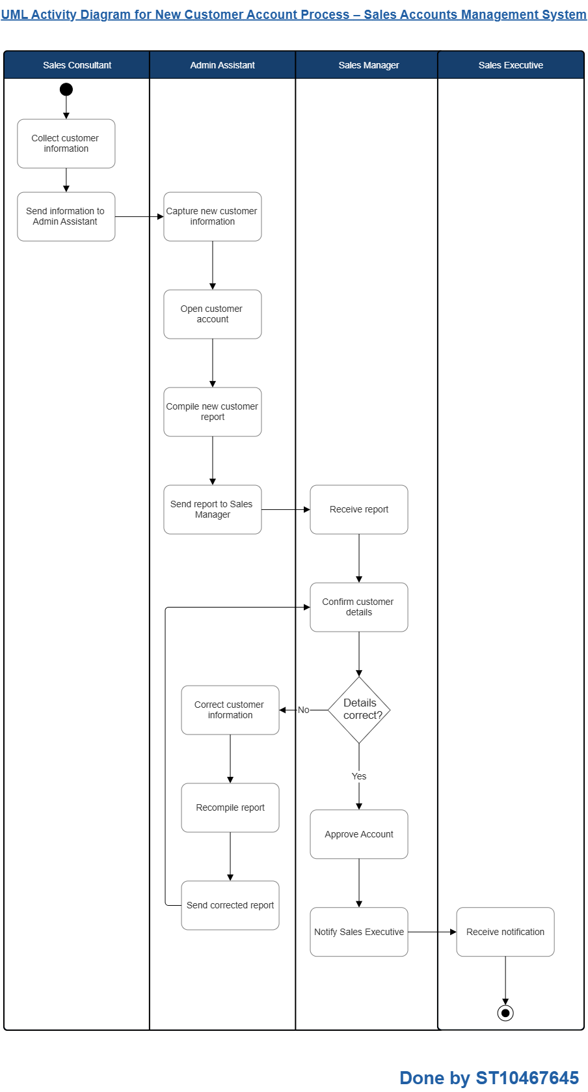
The following UML Activity Diagram illustrates the workflow for the new customer account process in the Sales Accounts Management System. The diagram was developed using the activity diagram notation given by Satzinger, Jackson and Burd (2015) and was drawn using SmartDraw (GeeksForGeeks, 2026).

4.2)

The following Domain Model Diagram was developed using the domain model diagram notation given by Satzinger, Jackson and Burd (2015) and drawn using draw.io :

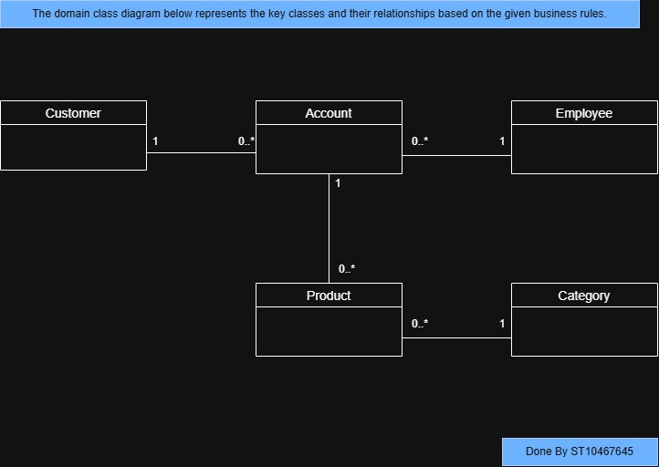

4.3)

A use case description is a detailed explanation of how a user interacts with a system to complete a specific task (The BA Doc, 2019). The following are three aspects included in a use case description as follows:
- Actor - the actor refers to the user or an external entity that interacts with the system. An actor is always outside the system and represents anything or anybody who will utilise the system (Satzinger, et al., 2015).
- Preconditions – the preconditions are those conditions that must be true prior to a use case beginning. These include what data or system state must already exist when the process begins (Satzinger, et al., 2015).
- Postconditions – the postconditions explain what must be true after a use case has been successfully completed. These include all data which was created, updated, or stored by the system (Satzinger, et al., 2015).

4.4)

Access control systems limit and control a user's access to system assets including files, applications, and databases. Access control systems utilise three main components as stated by Satzinger, Jackson & Burd (2015):
- Authentication - authentication is the method by which a user is identified when requesting access to a computer system. Typically, this occurs via username and password combinations. However, additional forms of authentication exist, such as biometric verification, and/or security questions. The function of authentication is to verify the user's identity prior to granting them access.
- Access Control List (ACL) - an ACL is a list tied to a particular asset that details which users or groups will be granted access to that asset and what level of access each group or user will receive. For example, certain users may only be able to view data, whereas other users may be allowed to modify or update that data. A user not listed in the ACL for a particular asset will be denied access to that asset.
- Authorisation - after verifying the user's identity, authorisation determines what action(s) an authorised user can perform within the system. In essence, authorisation provides the definition of permissible action(s) based upon permission levels defined in the ACL. Therefore, once the user has been validated, authorisation limits their ability to view or access data and perform actions that they are not permitted to perform.

References
AltexSoft, 2023. Functional and Nonfunctional Requirements: Specification and Types. [Online]
Available at: https://www.altexsoft.com/blog/functional-and-non-functional-requirements-specification-and-types/
[Accessed 02 April 2026].
Design4Users , n.d. UX Design: Types of Affordances in User Interfaces. [Online]
Available at: https://design4users.com/ux-design-types-of-affordances-in-user-interfaces/
[Accessed 12 April 2026].
GeeksForGeeks, 2026. Activity Diagrams - Unified Modeling Language (UML). [Online]
Available at: https://www.geeksforgeeks.org/system-design/unified-modeling-language-uml-activity-diagrams/
[Accessed 13 April 2026].
GeeksforGeeks, 2026. Functional and Non Functional Requirements. [Online]
Available at: https://www.geeksforgeeks.org/software-engineering/functional-vs-non-functional-requirements/
[Accessed 02 April 2026].
IBM, 2025. Vision document. [Online]
Available at: https://www.ibm.com/docs/en/engineering-lifecycle-management-suite/doors-next/7.0.3?topic=requirements-vision-document
[Accessed 01 April 2026].
IxDF, n.d. Affordances. [Online]
Available at: https://ixdf.org/literature/topics/affordances
[Accessed 12 April 2026].
Medium, 2017. Don Norman’s Principles of Interaction Design. [Online]
Available at: https://medium.com/@sachinrekhi/don-normans-principles-of-interaction-design-51025a2c0f33
[Accessed 12 April 2026].
Nielsen Norman Group , 2012. Usability 101: Introduction to Usability. [Online]
Available at: https://www.nngroup.com/articles/usability-101-introduction-to-usability/
[Accessed 12 April 2026].
Nielsen Norman Group, 2018. Visibility of System Status (Usability Heuristic #1). [Online]
Available at: https://www.nngroup.com/articles/visibility-system-status/
[Accessed 12 April 2026].
Nielsen Norman Group, 2019. How to Measure Learnability of a User Interface. [Online]
Available at: https://www.nngroup.com/articles/measure-learnability/
[Accessed 12 April 2026].
Reqtest, 2012. Why is the difference between functional and Non-functional requirements important?. [Online]
Available at: https://reqtest.com/en/knowledgebase/functional-vs-non-functional-requirements/
[Accessed 02 April 2026].
Satzinger, J. W., Jackson, R. & Burd, S., 2015. Systems Analysis and Design in a Changing World. 7th ed. Boston: Cengage Learning.
The BA Doc, 2019. Use Case Description Basics. [Online]
Available at: https://thebadoc.com/ba-techniques/f/use-case-description-basics
[Accessed 14 April 2026].

